📘 Assignment: Wireless Technology

🔹 Task 1: Scan Available Wi-Fi Networks
Objective: Scan nearby Wi-Fi networks and identify whether they are secured or open.
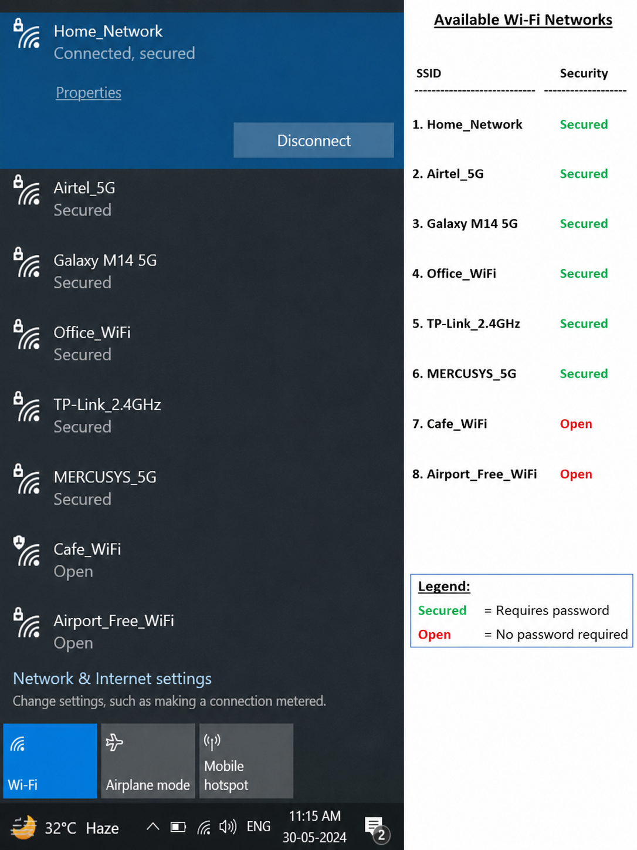
Task 2: Set Up a Mobile Hotspot and Check the Laptop's IP Address
Objective: Connect a laptop to your phone's hotspot and identify the assigned IP address.
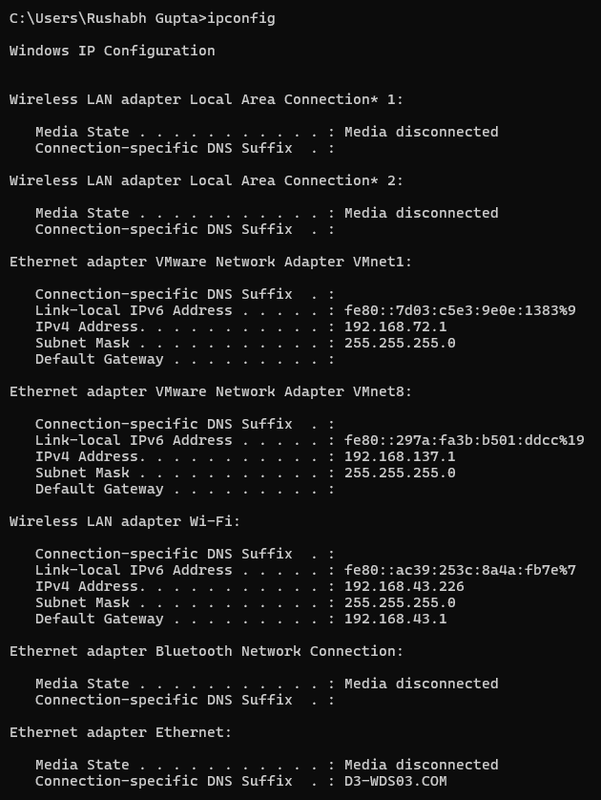
Result
Parameter | Value
Network Adapter | Wireless LAN adapter Wi-Fi
IPv4 Address (Assigned by Hotspot) | 192.168.43.226
Subnet Mask | 255.255.255.0
Default Gateway (Phone/Hotspot IP) | 192.168.43.1

Task 3: Difference Between WPA2 and WPA3
Answer:
What is WPA2?
WPA2 (Wi-Fi Protected Access 2) is a wireless security protocol that encrypts data transmitted over Wi-Fi networks using AES (Advanced Encryption Standard). It has been the standard for securing wireless networks for many years.
What is WPA3?
WPA3 (Wi-Fi Protected Access 3) is the latest Wi-Fi security standard. It provides stronger encryption, better protection against password-guessing attacks, and improved security for public Wi-Fi networks.
Task 4: Real-World Public Wi-Fi Cyberattack
Incident: UK Railway Station Public Wi-Fi Hack (2024)
In September 2024, public Wi-Fi services at several major railway stations in the United Kingdom were compromised. Attackers gained access to the Wi-Fi landing page through a legitimate administrator account and replaced it with a malicious message. As a precaution, Network Rail disabled Wi-Fi services at multiple stations while the incident was investigated. No customer data was reported stolen, but the event demonstrated how compromised administrative access can affect public Wi-Fi infrastructure.
Summary
Attackers accessed the management system for public Wi-Fi and altered the content shown to users connecting to the network. Although the attack did not steal user data, it disrupted services and highlighted the importance of securing administrative accounts.
How the Attack Could Have Been Prevented
- Enable Multi-Factor Authentication (MFA) for administrator accounts.
- Use strong, unique passwords for network administration.
- Regularly monitor and audit administrator access.
- Keep networking equipment and management software updated with security patches.
- Restrict administrative access to trusted devices and networks.

